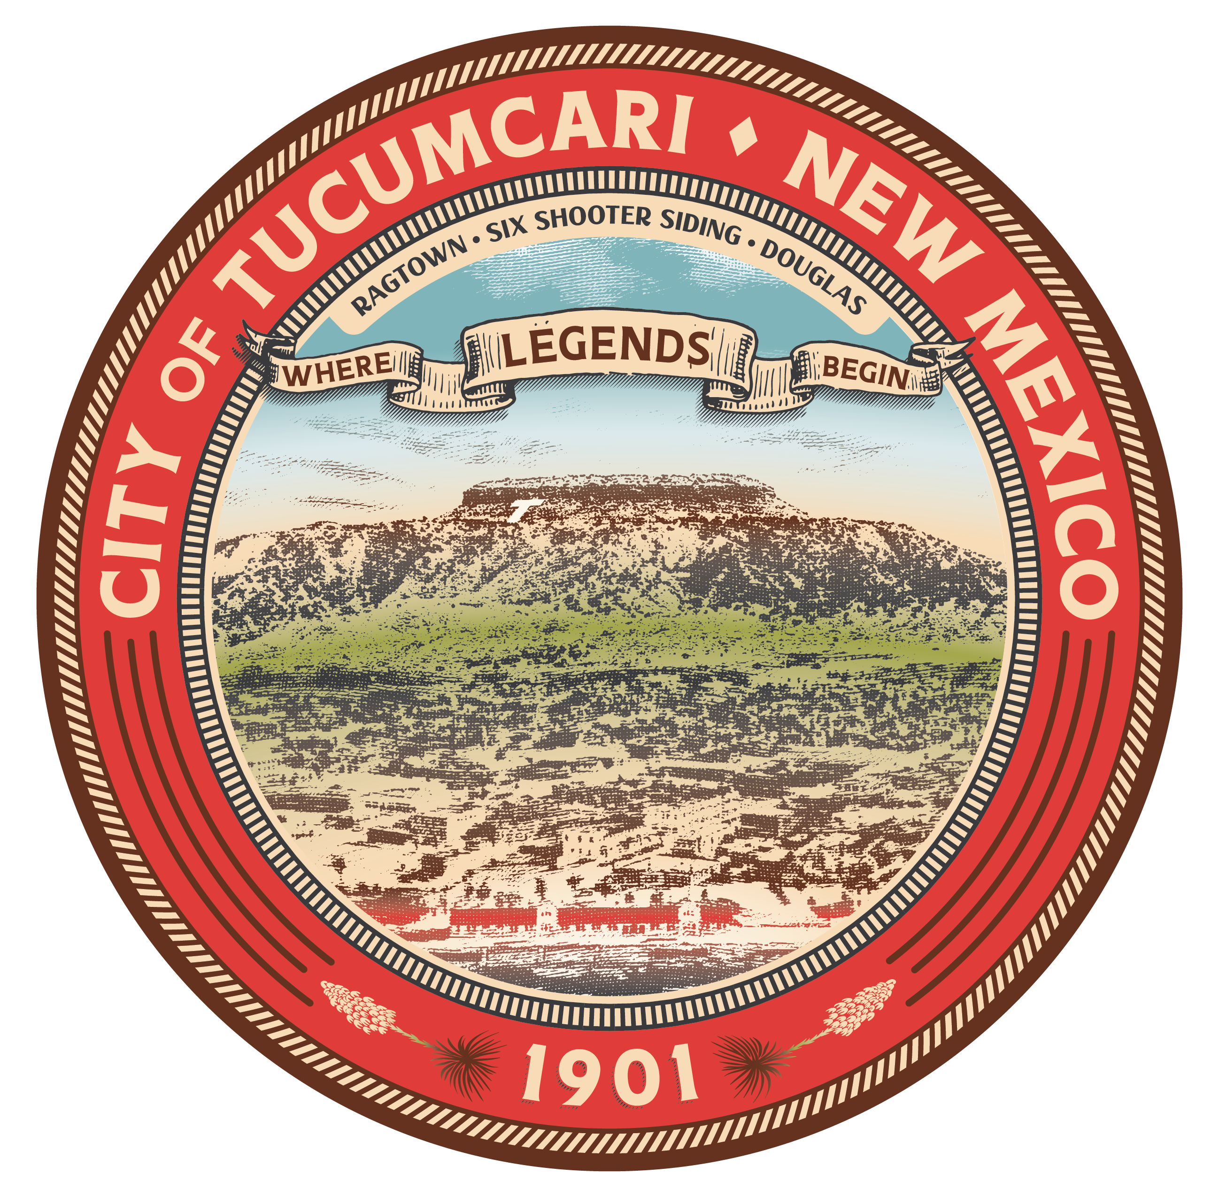

215 East Center Street
PO Box 1188
Tucumcari, NM 88401
575.461.3451

Marcy Willis
Mayor

Jonathan Brito
Mayor Pro Tem

Jerry Lopez
District 1 Commissioner

CJ Oglesby
District 3 Commissioner

Keith Hayes
District 4 Commissioner

Tania Addison
Interim City Manager



CityofTucumcari.com
VisitTucumcariNM.com

CITY OF TUCUMCARI

PUBLIC NOTICE
Please be advised that there may be a possible quorum at the Meet and Greet for the new City Manager, Mr. Jonathan Kirksey. This event will be held on Friday, October 16, 2026, immediately following the Special Commission Meeting, which is scheduled to begin at 8:30 a.m..
A quorum of the City Commission may be present at this event. No city business will be discussed, and no action will be taken.
This notice is provided in accordance with open meetings requirements.

Dated: October 12, 2026.
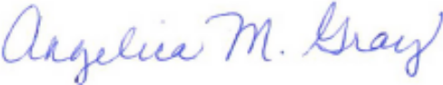

_____________________________

Angelica M. Gray, City Clerk

Emailed on October 12, 2026, to the following:

NM Eastern News (rwarnick@thenews.email)

KTNM/KQAY (karena@majesticcomm.com & lalo@majesticcomm.com)
Senior Citizens Center (seniors@cityoftucumcari.com)
Community Development Office (grantadmin@cityoftucumcari.com)
Tucumcari Public Library (library@cityoftucumcari.com)
Eastern Regional Housing Authority (desaray.tha@plateautel.net)

Posted on October 12, 2026, at the following location(s):

City Hall

Quay County Courthouse
City website: www.cityoftucumcari.com

